Practical 05:

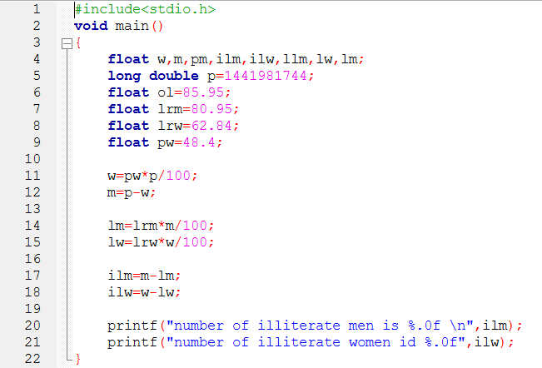

5-i:

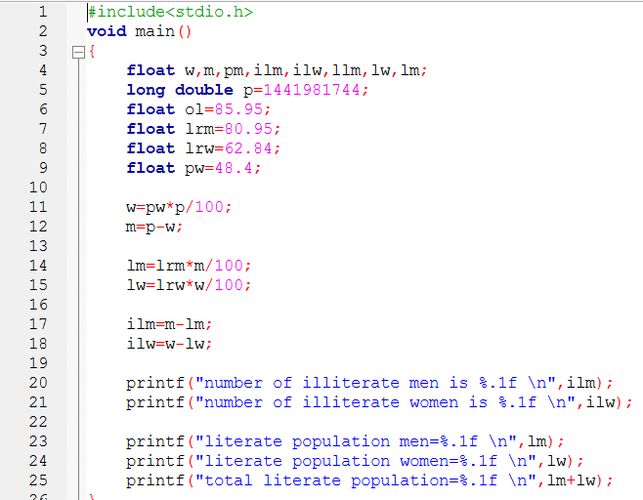

5-ii:

5-v:



